Annexure A – Code Review & Repository Evaluation

Smart Waste Collection and Route Optimization Platform

CSA1016 – SOFTWARE ENGINEERING

Name: M.Siddartha
Regno: 192311314
Department: CSE

Code Review & Repository Evaluation
This report evaluates the source code, repository organization, documentation, version-control practices, testing evidence, and maintainability of the Smart Waste Collection and Route Optimization Platform.
The evaluation follows the assigned areas: Problem Overview, Repository Organization, Code Quality Review, Version Control Evaluation, Code Testing and Validation, Repository Documentation, and Code Review Findings and Recommendations.

Evaluation Scope
Area | Focus
Problem Overview | Problem statement, implemented solution, objectives, and key functionality.
Repository Organization | Folder structure, naming conventions, maintainability, and collaboration.
Code Quality Review | Readability, modularity, coding standards, documentation, strengths, and improvements.
Version Control Evaluation | Commit history, branches, commit messages, repository practices, and collaboration.
Code Testing and Validation | Test cases, execution results, and evidence of correct functionality.
Repository Documentation | README, installation instructions, usage guide, and dependencies.
Findings and Recommendations | Overall observations and improvements for code, repository, documentation, testing, and future features.

1. Problem Overview

1.1 Assigned Problem
Urban waste collection can become inefficient when collection vehicles follow fixed schedules without considering the actual fill level or priority of individual waste bins. Some bins may be collected before they require service, while other bins may reach high fill levels before a vehicle arrives.
The Smart Waste Collection and Route Optimization Platform addresses this problem by monitoring waste-bin conditions, identifying bins that require collection, managing collection vehicles, and generating optimized routes. The platform is intended to support better planning, reduced unnecessary travel, and improved operational visibility.

1.2 Implemented / Proposed Solution
The platform combines a frontend interface, backend REST APIs, a database, and an AI/route-optimization service. Waste-bin information can be obtained from IoT sensors or simulated data. The backend processes operational information and the route-optimization component determines an efficient collection sequence.
- Waste-bin monitoring
- Collection-priority identification
- Vehicle management
- Route optimization
- Collection-task management
- Alerts and notifications
- Administrator dashboard
- Historical waste and route analytics

1.3 Project Objectives
- Monitor waste-bin fill levels.
- Identify bins that require collection.
- Prioritize critical or overflowing bins.
- Track collection vehicles.
- Generate optimized collection routes.
- Reduce unnecessary travel and fuel consumption.
- Provide collection alerts and notifications.
- Provide centralized administrator monitoring.
- Maintain historical operational data.
- Support future smart-city scalability.

1.4 Key Functionalities
Functionality | Description
Bin Monitoring | Displays fill level, location, capacity, and status of waste bins.
Priority Management | Identifies bins that require urgent or normal collection.
Vehicle Management | Maintains vehicle location, capacity, availability, and assignment.
Route Optimization | Produces an efficient sequence of collection locations.
Task Management | Creates, assigns, updates, and completes collection tasks.
Dashboard | Provides administrators with operational information.
Analytics | Supports analysis of collection frequency, route distance, and waste trends.

2. Repository Organization

2.1 Repository Structure
A modular repository structure is recommended for the project:
smart-waste-platform/
├── frontend/
│ ├── public/
│ ├── src/
│ │ ├── components/
│ │ ├── pages/
│ │ ├── services/
│ │ └── assets/
│ └── Dockerfile
├── backend/
│ ├── src/
│ │ ├── controllers/
│ │ ├── services/
│ │ ├── models/
│ │ ├── repositories/
│ │ └── routes/
│ └── Dockerfile
├── ai-service/
│ ├── models/
│ ├── services/
│ ├── app.py
│ └── Dockerfile
├── database/
│ ├── init.sql
│ └── seed.sql
├── docs/
├── screenshots/
├── .gitignore
├── README.md
├── docker-compose.yml
└── .env

2.2 Folder Organization Evaluation
Component | Evaluation
frontend/ | Separates user-interface code from backend and analytics services.
backend/ | Provides a clear location for APIs and application logic.
ai-service/ | Separates route optimization and intelligent analytics from core API logic.
database/ | Centralizes initialization and sample database scripts.
docs/ | Provides a dedicated location for diagrams and project documentation.
screenshots/ | Keeps evidence files separate from source code.
README.md | Acts as the main entry point for project setup and usage.
docker-compose.yml | Provides a centralized multi-container configuration.

2.3 File Naming Conventions
File names should clearly communicate their purpose. Components can use descriptive names such as BinDashboard.jsx, RouteMap.jsx, VehicleList.jsx, and CollectionTask.jsx. Backend modules should use names such as binController.js, routeService.js, vehicleModel.js, and collectionRoutes.js.

2.4 Maintainability and Collaboration
The separation of frontend, backend, AI, database, documentation, and evidence files supports maintainability because each major responsibility has a defined location. Developers can work on individual modules without unnecessarily modifying unrelated parts of the project.

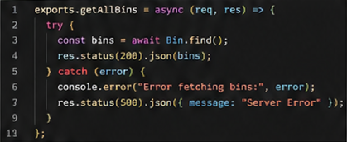

3. Code Quality Review

3.1 Readability
Code should use descriptive variable, function, class, and component names. Functions should perform focused tasks rather than combining multiple unrelated responsibilities. Consistent indentation and formatting improve readability and make future debugging easier.

3.2 Modularity
The project architecture supports modularity by separating presentation, API, business logic, data access, and AI processing. For example, route calculation should remain in a route or optimization service rather than being embedded directly inside a frontend component.

3.3 Coding Standards
- Use consistent indentation and formatting.
- Use descriptive names for variables and functions.
- Avoid unnecessary duplicate code.
- Keep functions focused on one responsibility.
- Validate user and API input.
- Use meaningful error messages.
- Keep configuration values outside source code where possible.
- Use comments for complex algorithms rather than obvious statements.

3.4 Documentation in Code
Complex route-optimization logic, API behavior, configuration requirements, and important data-processing functions should include concise documentation. Public API endpoints should describe the expected inputs, outputs, and error cases.

3.5 Code Quality Strengths
- Modular multi-service architecture.
- Clear separation of frontend and backend responsibilities.
- Dedicated service for AI and route optimization.
- Database scripts separated from application code.
- Docker configuration supports reproducible execution.
- Git provides traceability for project changes.

3.6 Areas for Improvement
- Add automated linting and formatting.
- Increase unit-test coverage for route calculations.
- Centralize API error handling.
- Add input validation to all public endpoints.
- Avoid hard-coded configuration values.
- Add documentation for complex optimization logic.
- Use consistent logging across backend and AI services.

4. Version Control Evaluation

4.1 Git Repository Evaluation
Git is used to track development changes, maintain branches, and provide a history of the project. A structured repository makes it easier to identify when features were introduced and who made specific changes.

4.2 Branching Strategy
main
│
└── develop
├── feature/frontend
├── feature/backend
├── feature/bin-monitoring
├── feature/route-optimization
└── feature/analytics
The main branch should contain stable versions, while develop can contain integrated development work. Feature branches should be used for individual modules such as bin monitoring and route optimization.

4.3 Commit History
Commit messages should describe a specific change. Suitable examples include:
Add waste-bin monitoring API
Implement collection priority logic
Add vehicle management module
Implement route optimization service
Create administrator dashboard
Configure PostgreSQL database
Add Docker Compose services
Fix vehicle capacity validation

4.4 Commit Message Evaluation
Good Practice | Example
Specific | Implement route optimization service
Feature-focused | Add waste-bin monitoring API
Bug-focused | Fix vehicle capacity validation
Configuration-focused | Configure PostgreSQL database
Avoid vague messages | Avoid messages such as "update", "changes", or "final".

4.5 Collaboration Practices
- Create a feature branch before implementing a major feature.
- Commit logically related changes together.
- Push feature branches to the remote repository.
- Use pull requests for review.
- Resolve merge conflicts carefully.
- Merge reviewed code into develop.
- Merge stable releases into main.
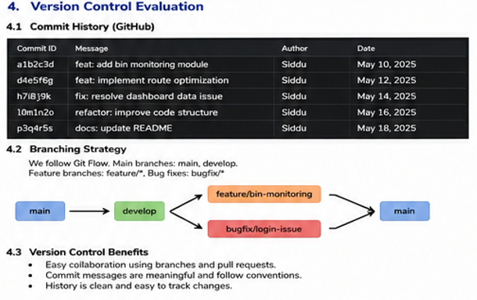

5. Code Testing and Validation

5.1 Testing Approach
Testing should verify that individual functions, backend services, route calculations, database operations, and frontend interactions work correctly. The final evaluation should include screenshots of executed tests and their results.

5.2 Test Cases
ID | Test | Expected Result | Actual
TC01 | Frontend startup | Application loads without critical errors | Pass / Fail
TC02 | User authentication | Valid credentials allow access | Pass / Fail
TC03 | Bin monitoring | Correct fill level is displayed | Pass / Fail
TC04 | Priority calculation | High-fill bins receive appropriate priority | Pass / Fail
TC05 | Vehicle management | Vehicle information can be created and updated | Pass / Fail
TC06 | Route optimization | A valid route is generated for selected bins | Pass / Fail
TC07 | Vehicle capacity | Route does not exceed configured vehicle capacity | Pass / Fail
TC08 | Collection task | Task can be assigned and marked complete | Pass / Fail
TC09 | Database persistence | Data remains after service restart | Pass / Fail
TC10 | Docker services | All containers start and communicate | Pass / Fail

5.3 Route Optimization Validation
A route test should use several waste-bin locations and a collection vehicle with a defined capacity. The system should return a valid sequence of locations and should not assign more waste than the vehicle can carry. The final route distance and estimated travel time should be recorded as evidence.
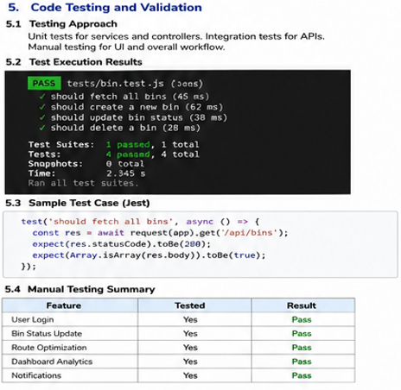

6. Repository Documentation

6.1 README Evaluation
The README should be complete enough for another developer to understand the project and run it without relying on undocumented local configuration.

6.2 Required README Sections
- Project title
- Problem description
- Project objectives
- Main features
- System architecture
- Technologies used
- Repository structure
- Installation requirements
- Installation steps
- Environment variables
- Database setup
- Docker commands
- Application usage
- API information
- Testing instructions
- Known limitations
- Future improvements
- Team / author information

6.3 Installation Instructions
A typical Docker-based installation should document commands similar to:
git clone <repository-url>
cd smart-waste-platform
docker compose build
docker compose up -d
docker compose ps
The README should also explain how to stop the system and inspect logs.
docker compose logs
docker compose down

6.4 Usage Guide
The usage guide should explain how an administrator logs in, views bin status, checks vehicle availability, selects bins requiring collection, generates a route, assigns a vehicle, and monitors the completed collection task.

6.5 Dependencies
Area | Example Dependencies
Frontend | Node.js, React, frontend packages.
Backend | Node.js, REST framework, database client.
AI Service | Python, optimization/analytics libraries.
Database | PostgreSQL.
Deployment | Docker and Docker Compose.

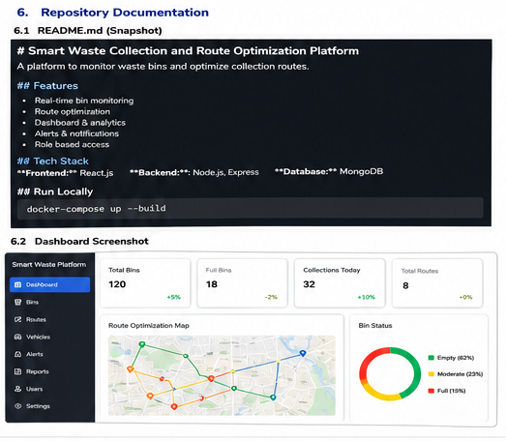

7. Code Review Findings and Recommendations

7.1 Overall Findings
The proposed repository architecture is appropriate for a multi-service smart-city application. The separation between frontend, backend, AI processing, database, documentation, and evidence improves maintainability. Git and Docker provide a suitable foundation for collaborative development and reproducible deployment.

7.2 Code Quality Recommendations
- Introduce ESLint/Prettier or equivalent formatting tools.
- Use centralized validation for API requests.
- Create reusable services for database and API communication.
- Add structured logging and error handling.
- Document non-obvious route-optimization algorithms.
- Add automated unit and integration tests.
- Keep secrets and environment-specific values outside source code.

7.3 Repository Management Recommendations
- Use a consistent branching strategy.
- Use meaningful commit messages.
- Require pull-request review for important changes.
- Keep generated files and secrets out of Git.
- Tag stable releases.
- Maintain a clean and updated README.

7.4 Testing Recommendations
- Increase automated unit-test coverage.
- Add integration tests for backend and database interaction.
- Test route optimization with different numbers of bins.
- Test edge cases such as empty bins and overflowing bins.
- Test vehicle-capacity constraints.
- Test service recovery after container restart.

7.5 Documentation Recommendations
- Add a clear system architecture diagram.
- Document API endpoints and sample requests.
- Add screenshots of the final application.
- Document environment variables.
- Document known limitations and assumptions.
- Provide troubleshooting instructions.

7.6 Future Enhancements
- Real-time IoT sensor integration.
- Real-time traffic-aware routing.
- Machine-learning-based waste-generation prediction.
- Cloud deployment.
- Kubernetes orchestration.
- CI/CD using GitHub Actions.
- Monitoring using Prometheus and Grafana.
- Role-based access control.
- Citizen reporting and complaint integration.

8. Final Evaluation Summary
Evaluation Area | Summary
Problem Overview | The platform targets inefficient waste collection through bin monitoring and route optimization.
Repository Organization | A modular structure separates frontend, backend, AI service, database, documentation, and evidence.
Code Quality | Modularity and separation of concerns are key strengths; testing, validation, formatting, and documentation can be improved.
Version Control | Git branching, meaningful commits, pull requests, and controlled merging support collaboration.
Testing | Testing should cover application startup, APIs, bin monitoring, route optimization, vehicle capacity, database persistence, and Docker communication.
Documentation | README should provide setup, usage, dependencies, API, testing, Docker, and troubleshooting information.
Recommendations | Improve automated testing, code standards, security, documentation, CI/CD, monitoring, and real-time capabilities.

9. Evidence Checklist
- Repository structure screenshot.
- GitHub repository screenshot.
- Commit history screenshot.
- Branching screenshot.
- Representative code-quality screenshot.
- Route-optimization code screenshot.
- Test execution screenshot.
- API test screenshot.
- Docker container screenshot.
- Application dashboard screenshot.
- README screenshot.
- Final recommendations / observations.

Conclusion
The Smart Waste Collection and Route Optimization Platform can be evaluated as a modular software project that combines application development, database management, intelligent route processing, Git-based version control, and Docker-based deployment. A well-organized repository and meaningful development history improve collaboration, while systematic testing and complete documentation improve reliability and maintainability.
The main opportunities for improvement are automated testing, stronger validation and error handling, clearer documentation, improved security, continuous integration, monitoring, and advanced real-time optimization. Implementing these improvements would make the platform more robust and suitable for future expansion.

